**Data VS Information**

Data is the unprocessed, unfiltered, and uncategorized form that is the precursor to information. Raw data is usually found in a form which can be interpreted as meaningless and/or useless until it has been processed. After data is processed and categorized it is transformed into information, which provides useful information to whoever views it with the proper amount of understanding.

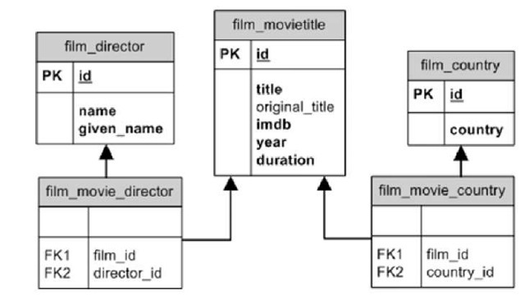

This example database contains data and presents information concerning movies in the database. Data in this diagram consist of the “things” contained within the tables without the context of the table itself (e.g. “Avatar”, 1990, Thailand, 2.42). The database organizes this meaningless data into information by sorting it into specific categories which serve to help identify what the data represents, in essence giving the data context. Given the diagram we can see where certain data will be stored (Film_Director>Name>”James Cameron”, Film_Movietitle>Title>”Avatar”, Film_MovieTitle>Year>2009, Film_Country>Country>”USA”). When comparing the usefulness of “2009” and “Avatar>Year>2009” we can see plainly that the latter is more useful, due to the fact that we can relate it to both what the data represents and to what it represents. Information is critical because it allows people viewing the information to make informed decisions and use the data properly without misinforming other parties involved.

**Data Models**

**Hierarchical Database Model**: Data in this pre-relational database model organizes data into tree-like structures, all of which span from a singular point. The data is stored in the form of records, which are connected to other records via links. This type of database model requires that each child record has only one parent, redundancy was a problems until later renditions, and does not cope well with data that does not exist in any predefined category.

**Network Database Model**: Considered to be the next step after the Hierarchical Model, in that it is more flexible than the previous iteration, mainly in that it does not require a child record to have only one parent. In the Network Model each record is capable of having multiple parents and children. Records are also considered Nodes and relationship types are comprised of arcs.

Both these types of database models were eventually supplanted by the “Relational Database”.

This was because the relational database model offered higher-level, and more declarative interfaces and accessibility to the data. As hardware became faster, the extra flexibility and interactivity of the relational database outweighed the previous benefited found in both the Network and Hierarchical models. The relational database also significantly reduced the problem of redundancies, and all the issues associated with it, due to the use of keys to reference to data, which limits the number of times that data must be inputting. This allows for a more modular database design and organization.

XML as a database model like many other, would depend on situation. However for the most part if the user is set on using a relational database, XML might be a good contender due to the number of formats that data may be stored in (CLOB, Shredded, or native XML). This versatility allows the database to adapt to any possible changes in the future, therefore making the database more module. XML also supports a number of API’s from BaseX to eXist and Sedna, this allows for a wider range of database management tools to be implemented without the need for extensive modifications. According to Steve O’Connell “one reason for the use of XML in databases: the increasingly common use of XML for [data transport](https://en.wikipedia.org/wiki/Transport_layer), which has meant that "data is extracted from databases and put into XML documents and vice-versa”.